**Week-1: HTML + CSS Assignment**

**Index.html**

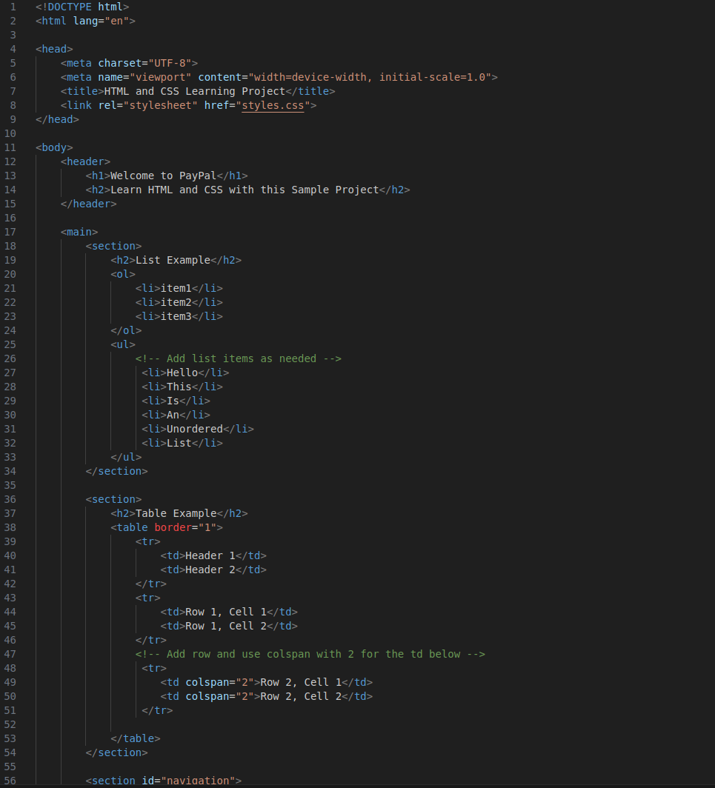

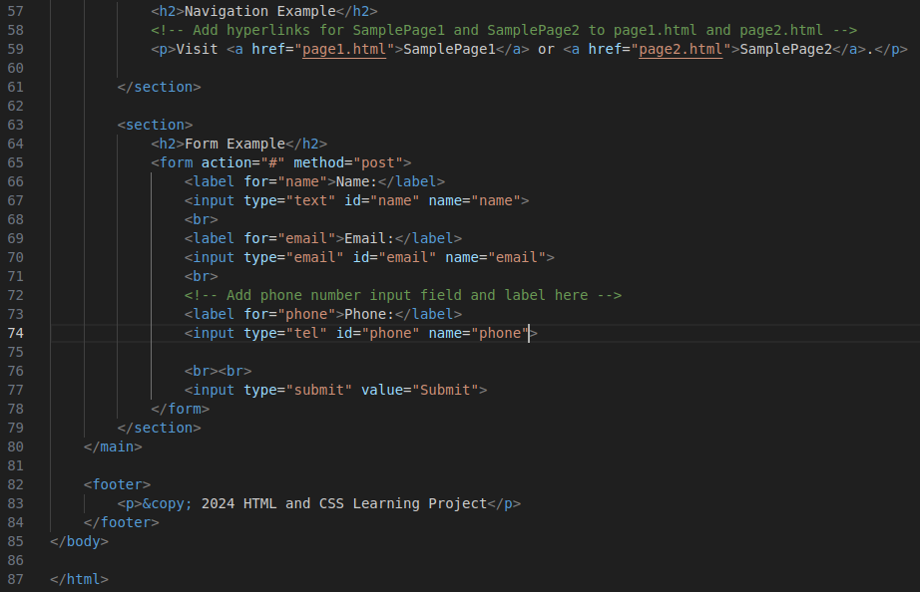

**Page1.html**

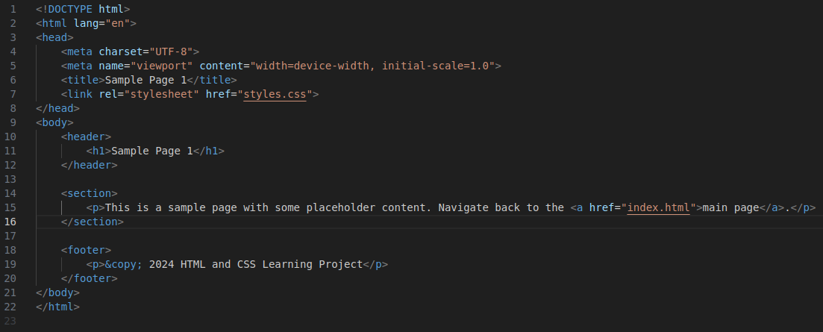

**Page2.html**

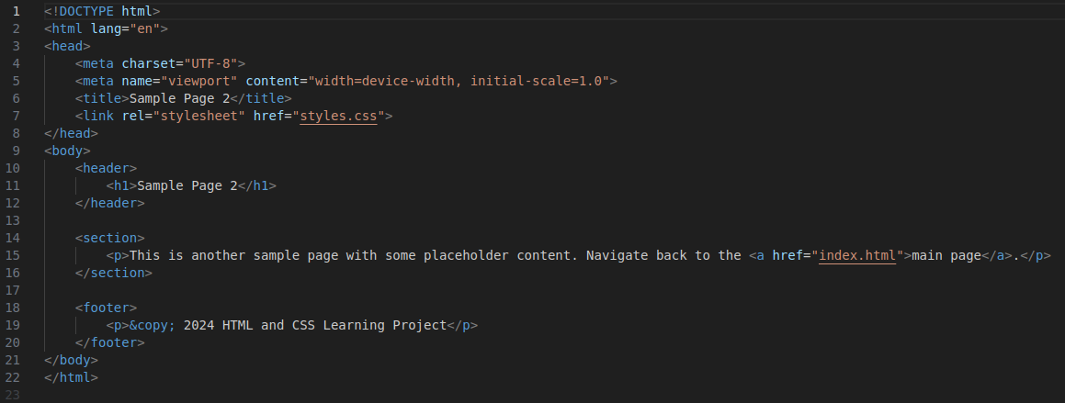

**Styles.css**

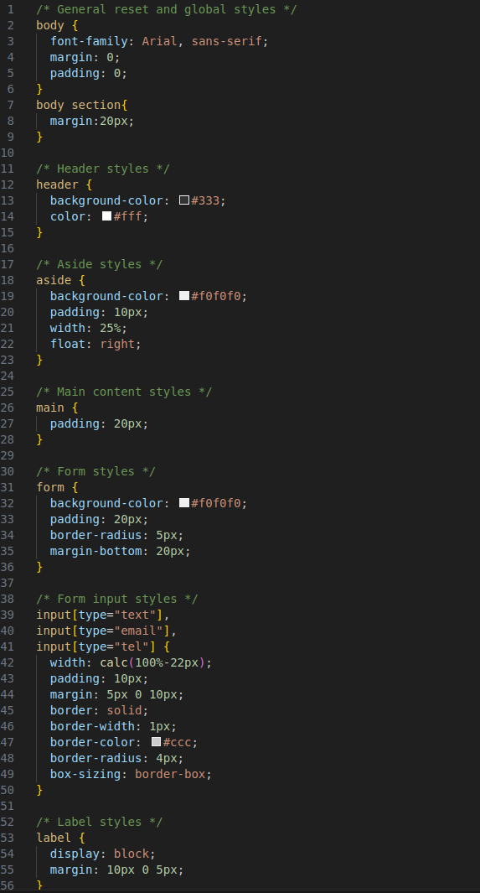

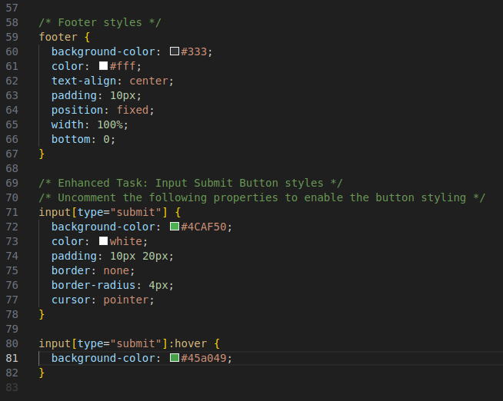

**Output –**

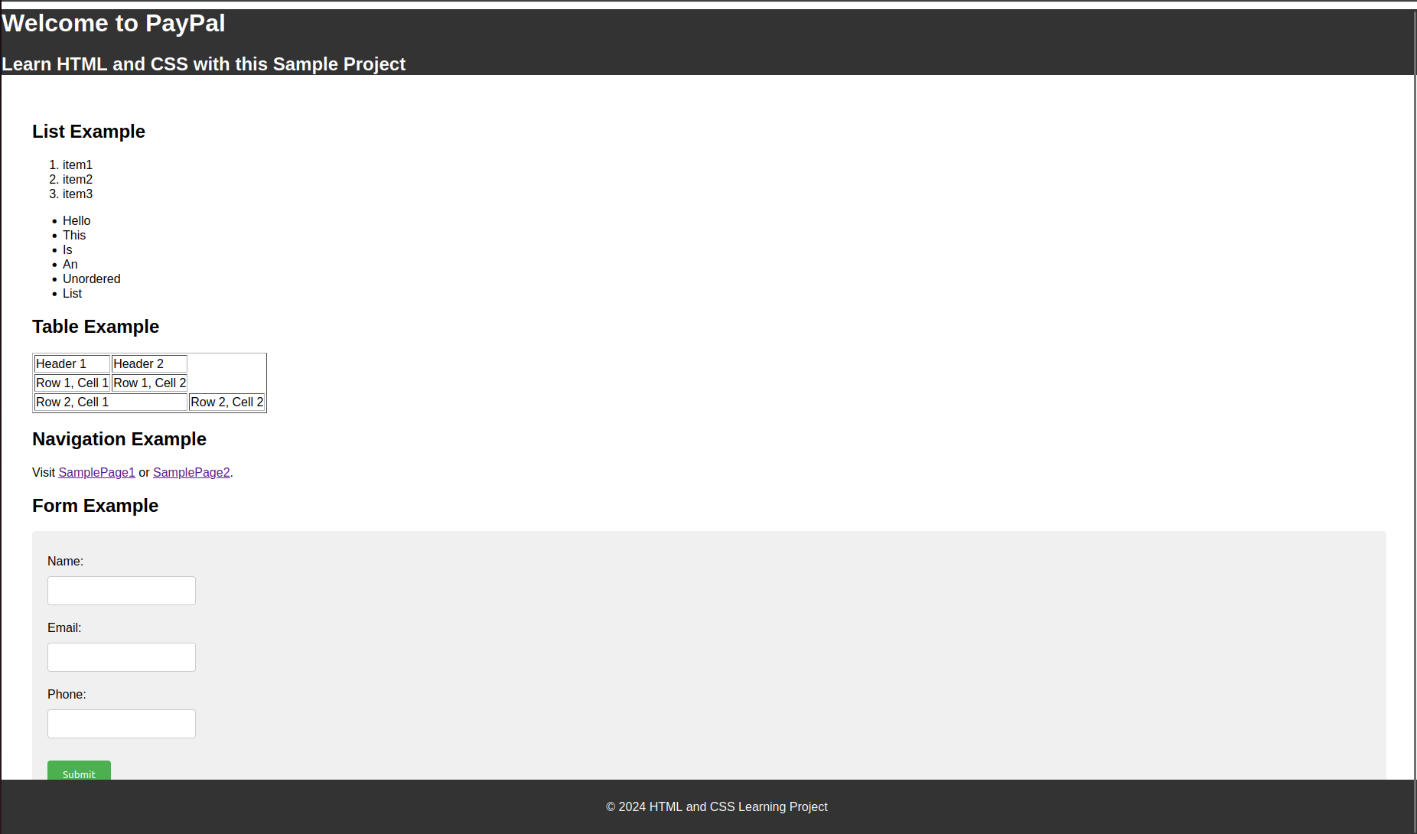

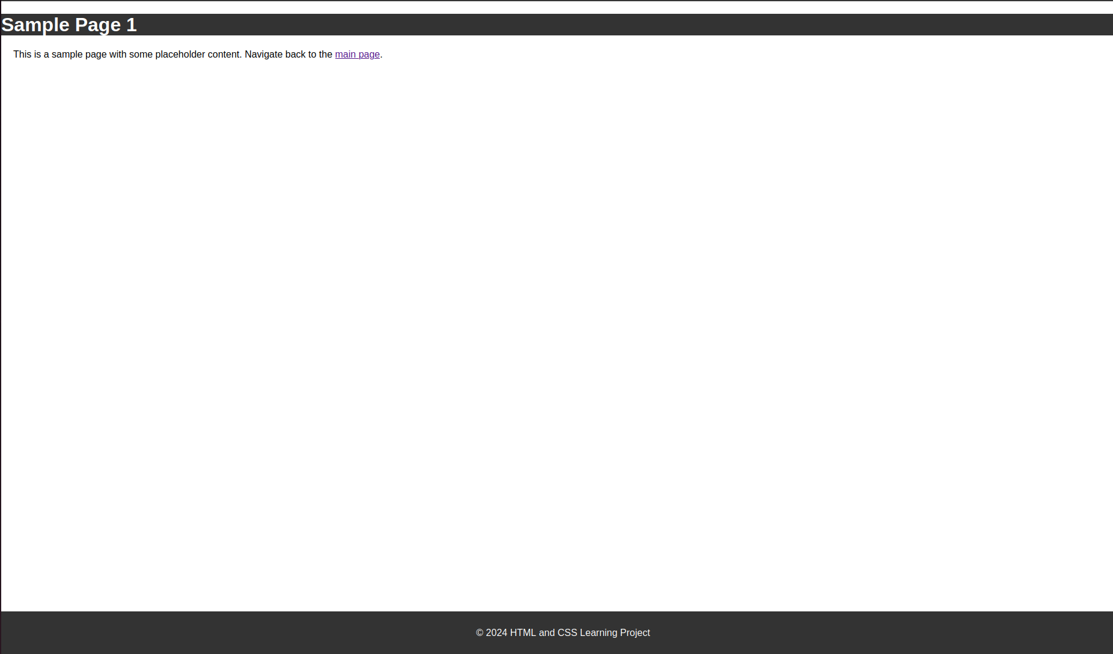

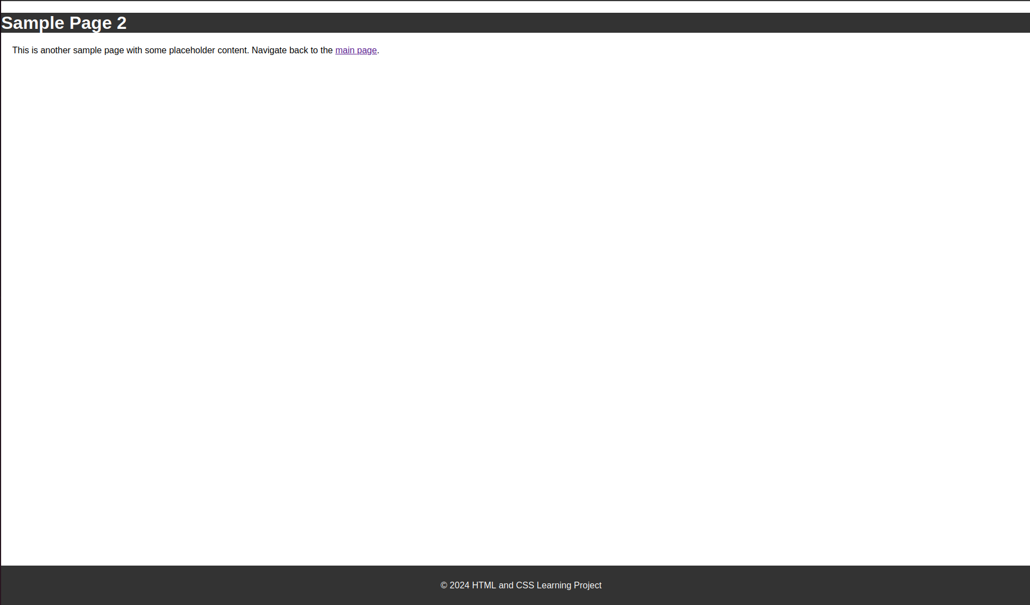

**Git & IntelliJ Assignment -**

1. **What is the use of the git add command?**

Git add command is used to stage the files. Staging the files means that they would be included in the next commit.

1. **Write the command to create a branch “feature-group”.**

Git branch feature-group

Or

Git checkout -b feature-group

1. **What is a pull request? Write the steps involved in creating a pull request.**

A pull request is a request created to merge the changes, allowing the owner of the branch to confirm the proposed changes before they are merged.

Fork the Repository -> Create a new branch -> make changes -> stage changes -> commit changes -> push changes -> go to the repo and click on create a pull request.

1. **How do you add collaborators?**

In your repo, there is an option to manage access, there we have the option to add collaborators via their emails.

1. **What is the command used to commit our changes in github repo?**

Git commit -m “Message”

Git push

1. **Create a github account and repository to save all your assignment tasks. Example repository name: rg-assignments**

<https://github.com/HarshitVijayKumar/rg-assignments>

1. **Create a branch called feature-java(you can use it later to push all your java related tasks to this branch)**



1. **Install IntelliJ IDE. Create a simple java project displaying “Hello World!!”and share the screenshot.**

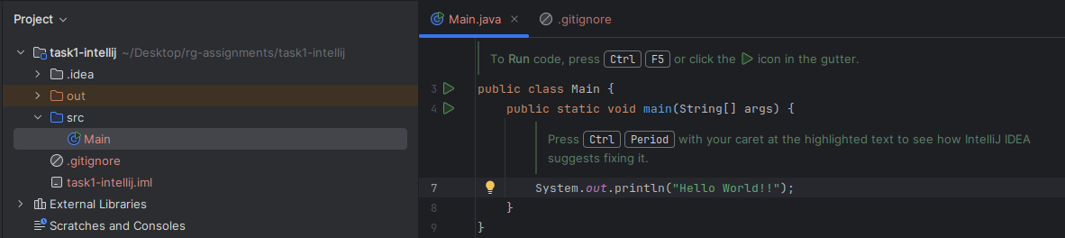

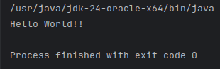

1. **In IntelliJ IDE, explore the shortcut keys for the following**
2. **To run the project**
3. **To select a line**
4. **To comment/uncomment a line**
5. **To delete a line**

a. Shift+F10

b. Ctrl + W

c. Ctrl + /

d. Ctrl + Y